NEWCASTLE UNITED CHURCH

84 Mill St. S. L1B 1H2 905-987-4515

newcastleunitedchurch@bellnet.ca www.newcastleunitedchurch.org

Rev. Mary-Jane Hobden, B.A., M. Div.

Joanne McLennan, A.R.C.T, L.T.C.L., Music Director

September 11, 2016 10:30 a.m.

**Season of the Spirit (Pentecost)**

## Praising God Together

### *Prelude*

### Processional Hymn: “There’s A Wideness” # 271

Lighting the Christ Candle

Call to Worship: *(responsive)*

*Some say there is no God.*

We are the people of God.

*We gather to celebrate our life together as community.*

We are the people of God.

*Let us worship together, for*

We are the people of God.

Prayer of Approach: *(unison)*

God of ongoing creation, God of Sabbath rest, tune us into the rhythms of your Spirit. We have moved into our fall routines, moving ever faster, working ever harder. Help us to pace ourselves to avoid burnout and stress. May this hour of worship allow us to quiet our hearts, our minds, and open us to the work of your Spirit that we might be renewed. In Jesus’ name we pray. Amen.

Our Life and Work

**Song:** “I Am The Light Of The World” # 87

**Sharing Time**

**The Lord’s Prayer**

**Our Father, who art in heaven, hallowed be thy name.**

**Thy kingdom come, thy will be done on earth as it is in heaven.**

**Give us this day our daily bread, and forgive us our trespasses,**

**as we forgive those that trespass against us.**

**And lead us not into temptation, but deliver us from evil,**

**For thine is the kingdom, the power and the glory, for ever and ever. Amen.**

**Song:** “We Are Marching” # 646

Celebrating the Word

**Jeremiah 4:11-12, 22-28** Earth shall mourn. Pew Bible Pg. 613

##### Psalm 14 The foolish say, “There is no God.” # 735

**Gospel of Luke 15:1-10** The lost sheep and the lost coin. Pew Bible Pg. 850

**Anthem:** “ My Savior” – words by Nancy Price and Don Besig, music by Don Besig

**Reader:** *The word of the Lord.*

**People: Thanks be to God.**

Message

**Hymn:** “A Woman and a Coin” # 360

**Thanksgiving**

##### The Offertory:

##### Presentation of our gifts and singing verse 3 of # 218

***With voices united our praises we offer,***

***and gladly our songs of thanksgiving we raise.***

***Our sins now confessing, we pray for your blessing,***

***to you, our great Redeemer, forever be praise!***

Dedication Prayer: *Minister*

Congregation: Amen.

*Prayers of Thanksgiving and Intercession*

## Sending Forth

**Closing Hymn:** “How Great Thou Art”# 238

### Benediction

### “Go Now in Peace” – Besig/Price *(words printed inside cover of VU)*

### *Postlude*



**Welcome!** We enjoy open seating so please, sit where you feel comfortable and meet a new friend. We are glad you have joined us this morning. Please sign our guest book, located in the narthex and we invite you to worship with us again.

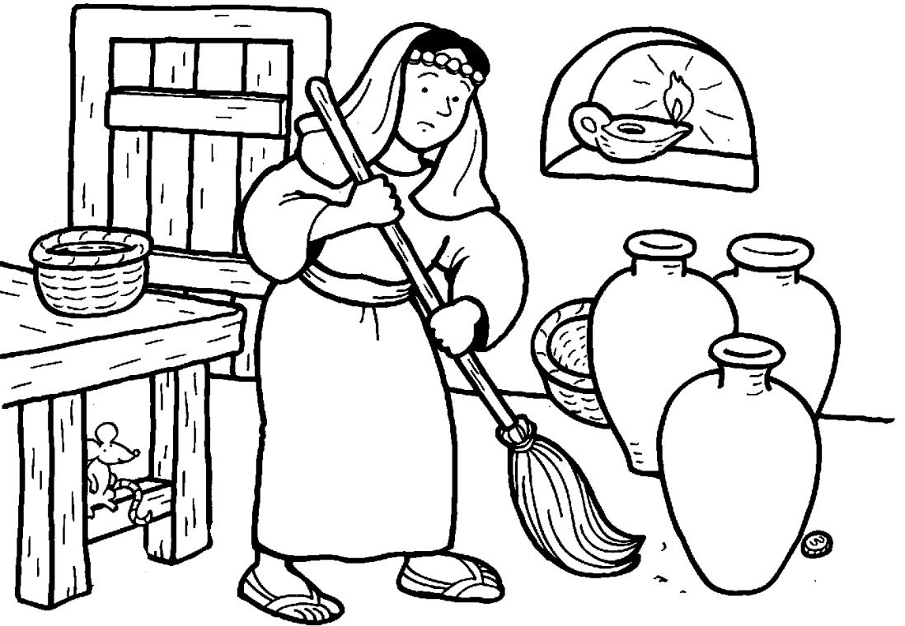

“Or what woman having ten silver coins, if she loses one of them, does not light a lamp, sweep the house and search carefully until she finds it?” – Luke 15: 8

**NEWCASTLE UNITED CHURCH**

**Greeting** you this morning are Carole and Gary Brunton.

**Nursery care** is provided for little ones to

age 4 from 10:20AM until the end of the worship service. The nursery is located in the narthex, through the doors on either side of the choir loft. Paige is our care provider.

Our BIBLOS reader is Joyce King, UCW representative to the Official Board.

**Faith In Motion** –

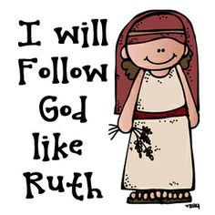**Holy Moly!** – our 5-9 year olds are learning the story of Naomi and Ruth: good friends stick together through famine, death, and distance. Our Key Bible verse is Ruth 1: 16.

**Connect!** – young people ages 10-12 and **Youth Bible Study Group** – ages 13+. Both groups are together these next few weeks for a Discipleship Unit on The Lord’s Prayer – “why should I pray the Lord’s Prayer when it feels like I’m just going through the motions”. Our scriptures are Matthew 6: 9-13 and Matthew 6:7.

The sympathy and prayers of the congregation are extended to Annette, Doug, Jenna and Julia Nugent, family and friends on the passing of Annette’s father Doug Rowe. The service was held at Morris Funeral Chapel on Friday, September 9. The U.C.W. provided lunch in the church hall following.

**Today**– The Stewards host a hot dog and corn-on-the-cob lunch after worship and everyone is invited to join us. Many thanks to John and Jo-Anne Smithson for providing the corn and hot dogs. Freewill donations will be gladly received.

**Cheese Campaign** the Stewards offer this Empire cheese fundraiser for the operating expenses of our church. Order forms are available from the table in the narthex. Extra forms for family/friends are also available in the narthex. Pricing is not included on the form as the cheese is priced when packaged, however they are comparable to those in grocery stores. Delivery will be Wednesday, September 28 so orders are due by September 18. Thank you for your support.

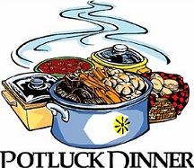**Monday, September 12** – the U.C.W. meets for a Pot Luck Dinner in the church hall at 6PM. Rev. Mary-Jane will be there if you haven’t had the opportunity to meet and chat with her. All ladies are most welcome.

**Tuesday, September 13** – the Official Board meets at 7PM in the church hall.

**Thursday, September 15** – Choir practice from 7-9PM in the sanctuary. If you would like to join our music ministry, please speak with Joanne after church or 905 987 5894.



**Friday, September 16** – the young people and leaders host **Board Games Night** from 7-8:30PM in the church hall. Refreshments and fun! Everybody is welcome.

Marg Tait is looking for someone to replace her as the sanctuary decorations co-ordinator as she will no longer be looking after the flowers after this Christmas. Please call Marg 905 987 4242.

**Messy Church!** Fresh ideas for building a Christ-centred community. Join us for this unique approach to church for everyone – all ages, all abilities – on Friday, **September 30** from 10:30AM until 1PM. We Chill (gather), Create! (activities), Celebrate! (worship) and Chomp! (enjoy a meal together). Please let Lorna, Susan, Janet or Robin know if you would like to come.

**Covenanting Service** between the congregation and Rev. Mary-Jane Hobden will be held here on Sunday, October 2 at 7PM. Everyone is invited to join us as we celebrate this special occasion. Refreshments following provided by the Congregational Life Cte. and the Joint Search Committee.

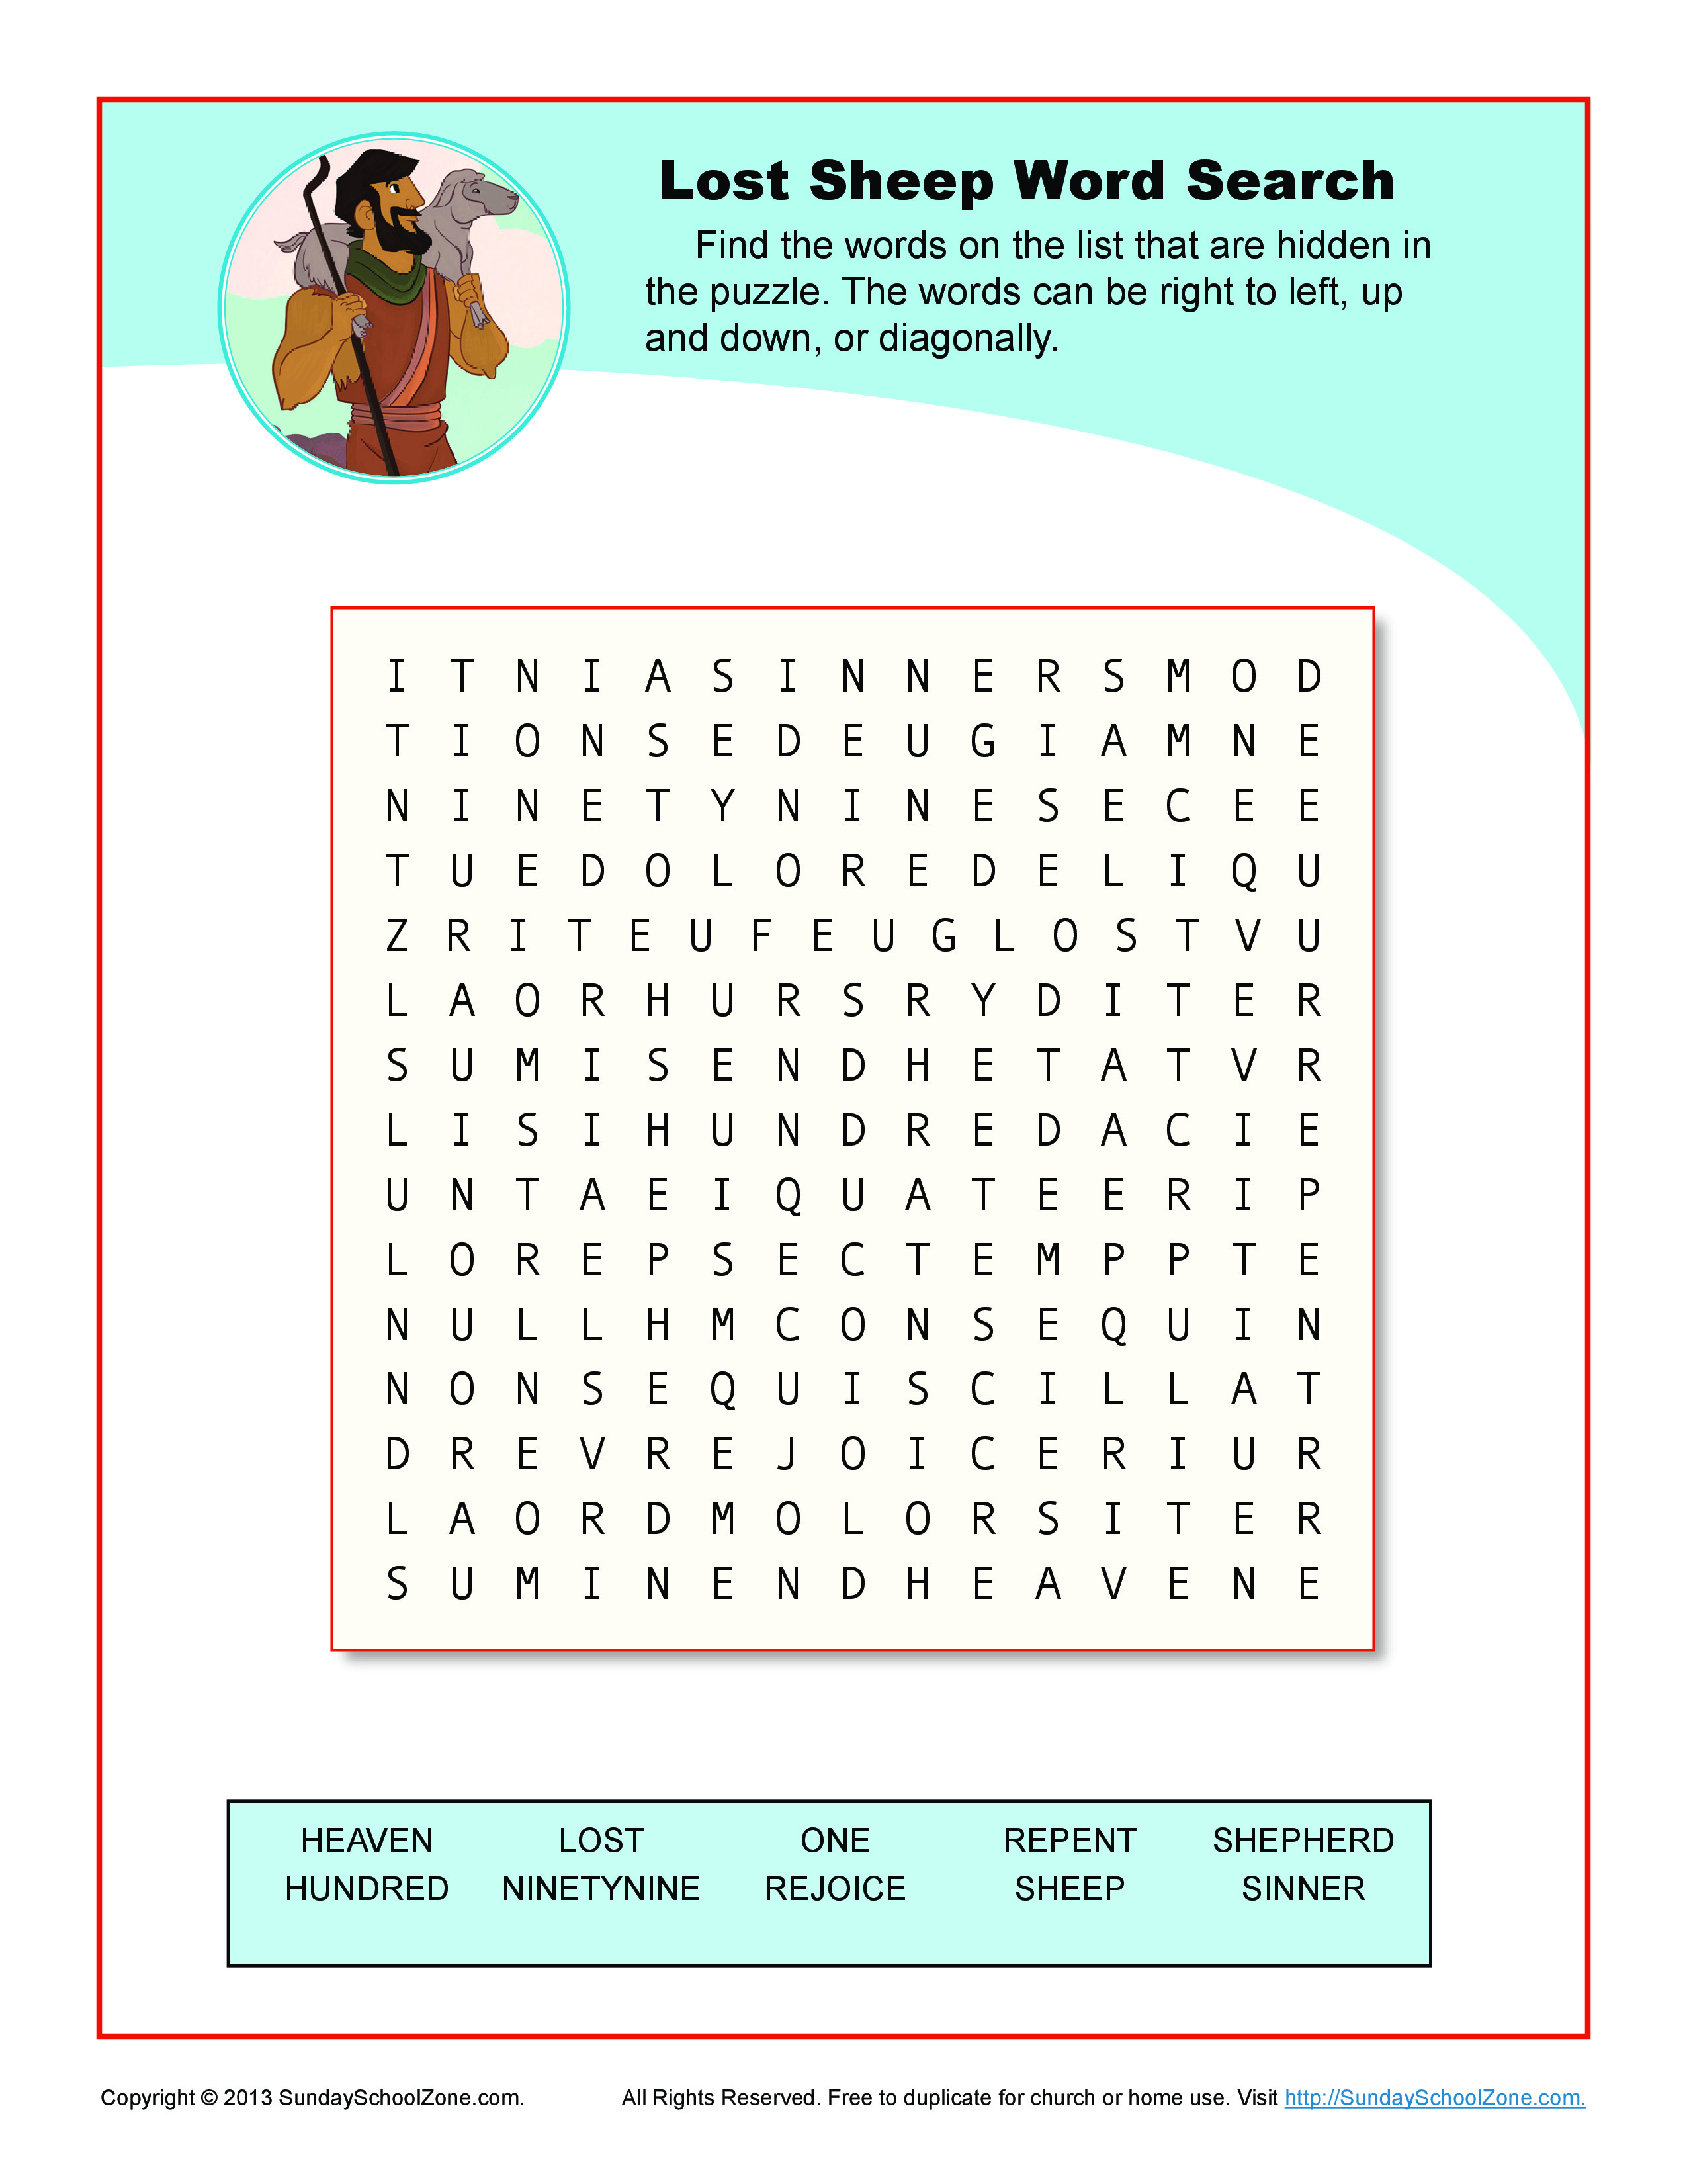

Announcements

September 11, 2016